
Semester Two Examination, 2024
Question/Answer booklet

MATHEMATICS METHODS
UNITS 3&4
Section One: Calculator-free

Your name

Your Teacher’s name

Time allowed for this section
Reading time before commencing work: five minutes
Working time: fifty minutes

Materials required/recommended for this section
To be provided by the supervisor
This Question/Answer booklet
Formula sheet

To be provided by the candidate
Standard items: pens (blue/black preferred), pencils (including coloured), sharpener,
correction fluid/tape, eraser, ruler, highlighters

Special items: nil

Important note to candidates
No other items may be taken into the examination room. It is your responsibility to ensure that you do not have any unauthorised material. If you have any unauthorised material with you, hand it to the supervisor before reading any further.

Question | Mark | Max | Question | Mark | Max
1 |  | 4 | 5 |  | 6
2 |  | 7 | 6 |  | 5
3 |  | 5 | 7 |  | 7
4 |  | 8 | 8 |  | 8

Structure of this paper

Section | Number of  questions  available | Number of  questions to  be answered | Working  time  (minutes) | Marks  available | Percentage  of  examination
Section One:  Calculator-free | 8 | 8 | 50 | 50 | 33
Section Two:  Calculator-assumed | 11 | 11 | 100 | 102 | 67
 |  |  |  | Total | 100

Instructions to candidates

1. The rules for the conduct of examinations are detailed in the school handbook. Sitting this examination implies that you agree to abide by these rules.

2. Write your answers in this Question/Answer booklet preferably using a blue/black pen.
Do not use erasable or gel pens.

3. You must be careful to confine your answers to the specific question asked and to follow any instructions that are specific to a particular question.

4. Show all your working clearly. Your working should be in sufficient detail to allow your answers to be checked readily and for marks to be awarded for reasoning. Incorrect answers given without supporting reasoning cannot be allocated any marks. For any question or part question worth more than two marks, valid working or justification is required to receive full marks. If you repeat any question, ensure that you cancel the answer you do not wish to have marked.

5. It is recommended that you do not use pencil, except in diagrams.

6. Supplementary pages for planning/continuing your answers to questions are provided at the end of this Question/Answer booklet. If you use these pages to continue an answer, indicate at the original answer where the answer is continued, i.e. give the page number.

7. The Formula sheet is not to be handed in with your Question/Answer booklet.
Section One: Calculator-free (50 Marks)
This section has eight questions. Answer all questions. Write your answers in the spaces provided.

Working time: 50 minutes.

Question 1 (4 marks)

The random variable $X$ denotes the number of people who cross a particular road in a ten-minute interval.

The random variable is found to have the following probability distribution:

$$x$$ | $$0$$ | $$1$$ | $$2$$ | $$3$$ | $$4$$ | $$5$$
$$Pr⁡(X=x)$$ | $$a$$ | $$2a$$ | $$4a$$ | $$4a$$ | $$8a$$ | $$a$$

(a) Show that $a=0.05$. (1 mark)

(b) Determine the expected number of people who will cross this intersection in a ten-minute interval. (2 marks)

During the morning it is thought that a better model would be described by the random variable $Y$, where $Y=2X+1$.

(c) Determine the expected number of people who will cross this intersection in a ten-minute interval in the morning. (1 mark)

Question 2 (7 marks)
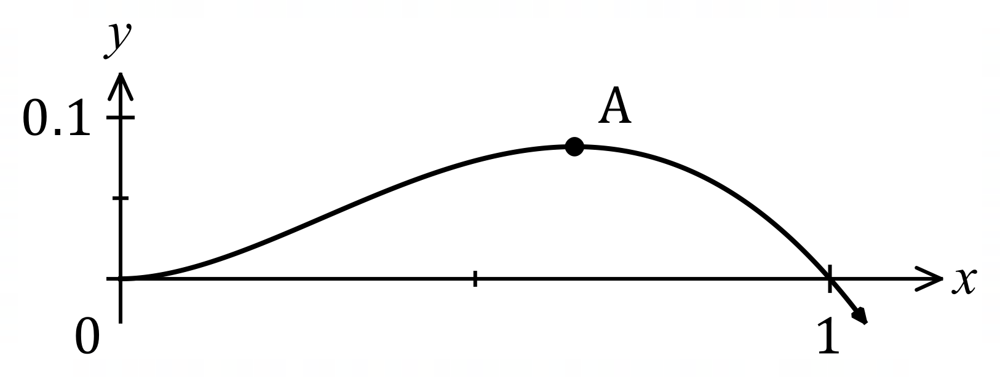
The graph of $y=f(x)$ is shown,
where $f\left(x\right)=x^{2}\left(1-\sqrt{x}\right)$.

(a) Determine the $x$-coordinate of the stationary point marked $A$ in the graph. (4 marks)

(b) Determine the area between the curve and the $x$-axis between $x=0$ and $x=1$.
(3 marks)

Question 3 (5 marks)
(a) Express using natural logarithms, the $x$-coordinate of the point where the curve $y=3^{-x}$ intersects with the curve $y=5^{2-3x}$. (3 marks)

(b) Given that $f(x)$ has domain $x>-3$, has derivative $f^{'}\left(x\right)=\begin{matrix}1 \\ \overline{x+3}\end{matrix}$, and the curve $y=f(x)$ passes through the point $(-2, 5)$, determine an expression for $f(x)$. (2 marks)

Question 4 (8 marks)
Determine the following:

(a) $\int{\underset{ }{18\sin\left(6x+1\right)}}dx$. (2 marks)

(b) $\int_{2}^{3}{\begin{matrix}d \\ \overline{dx}\end{matrix}\left(\cos\left(\begin{matrix}πx \\ \overline{ 3 }\end{matrix}\right)\right) }dx$. (2 marks)

(c) $\int_{1}^{4}{\underset{ }{\sqrt{3x-3}}}dx$. (2 marks)

(d) $\begin{matrix}d \\ \overline{dy}\end{matrix}\int_{y}^{-1}{(1-\underset{ }{{3e}^{2x+π})}}dx$. (2 marks)

Question 5 (6 marks)

The time taken to wait for a self-service checkout in a supermarket, $X$ minutes, is a continuous random variable.

The wait time is modelled by the cumulative distribution given by

$$F\left(x\right)=-\left(2x+1\right)e^{-2x} where x≥0$$

(a) Determine the exact probability that a customer will wait between two and three minutes for a self-service checkout. (2 marks)

(b) Show that the probability density function is given by $f\left(x\right)=4xe^{-2x}$. (3 marks)

A graph of $f\left(x\right)=4xe^{-2x}$ is shown below.

(c) Illustrate your solution to part (a) on the graph given below. (1 mark)

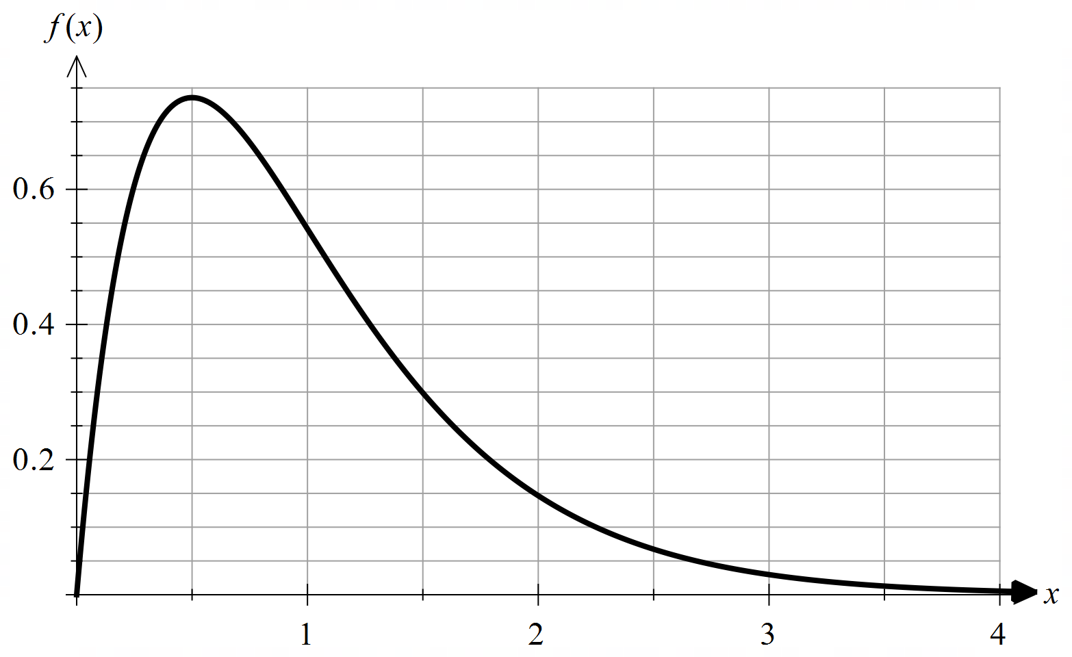

Question 6 (5 marks)

(a) A survey of 400 randomly selected Year 12 students found 20% of them were in favour of shorter summer holidays.

Using $z=2$, determine an approximate 95% confidence interval for the proportion of all Year 12s in favour of shorter summer holidays. (3 marks)

(b) In order to estimate how many people would vote for a particular political party, $p$, a group of randomly selected voters is surveyed. The survey resulted in a $95\%$ symmetrical confidence interval of $0.498<p<0.522$.

Below are five statements about this confidence interval. Tick the two correct statements.
(2 marks)

The probability that a randomly selected voter will vote for the party is between $0.498$ and $0.522$.
A 90% confidence interval determined based on the data collected would have a smaller interval width.
Assuming that the proportion of voters in the sample remains the same, increasing the sample size would lead to a reduction in the 95% confidence interval.
The probability that party A will receive a vote share of more than 52.2% is 5%.
A majority of voters would vote for this political party in an election.

Question 7 (7 marks)
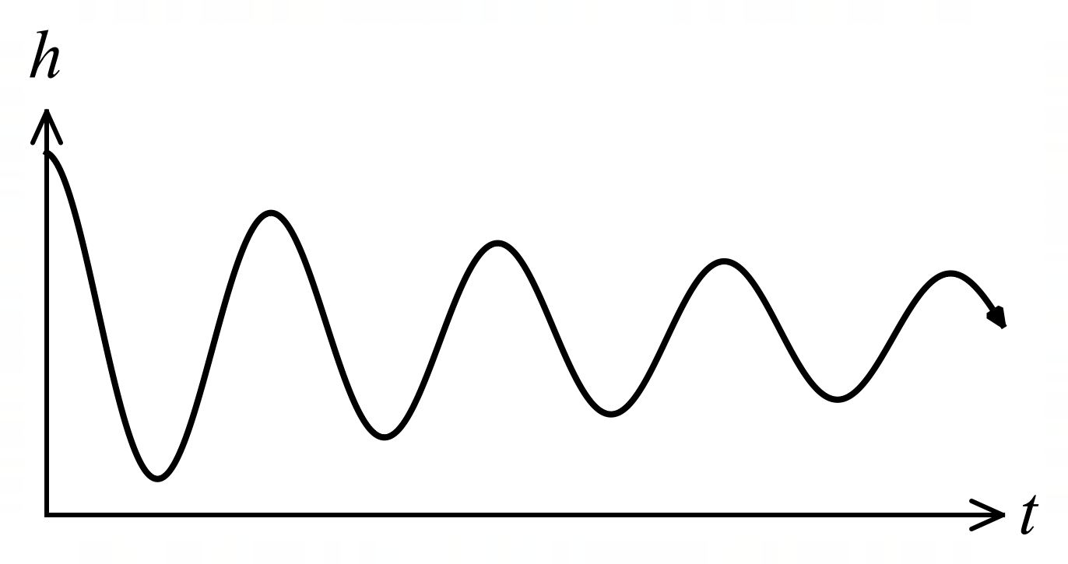
The graph shows the height $h$ cm of
a small mass suspended by a spring
above a bench top $t$ seconds after it
was released, where
$$h=3+\frac{3\cos\left(4πt\right)}{t+1}.$$

(a) Calculate the height of the mass when $t=1$. (1 mark)

(b) Determine the rate of change of height of the mass when $t=1$. (3 marks)

(c) Use the increments formula to estimate the height of the mass when $t=1.1$. (3 marks)

Question 8 (8 marks)

(a) Show using calculus that the derivative of $y=\tan{x}$ is $\frac{dy}{dx}=1+\tan^{2}{x}$. (3 marks)

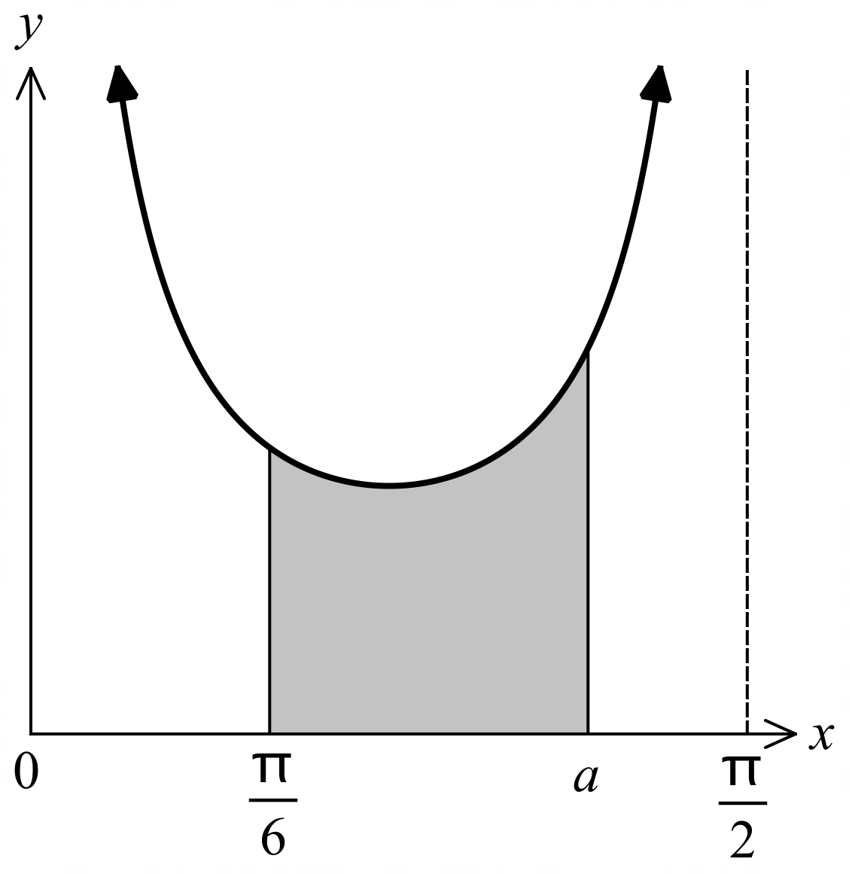
The diagram on the right shows the graph of

$$y=\frac{1+\tan^{2}{x}}{\tan{x}}$$

for $0≤x≤\frac{π}{2}$.

The shaded area is bounded by the curve, the $x$-axis and the lines $x=\frac{π}{6}$ and $x=a$.
(Note: Diagram is not drawn to scale.)

(b) Using part (a), determine the exact value of $a$ if the shaded area is $\ln{3}$ square units.
(5 marks)

Supplementary page

Question number: _________

